NOMBRE DE LA ASIGNATURA O UNIDAD TEMÁTICA
Título del documento que
puede ser desde una línea
hasta tres de extensión
Loremipsum dolor sitamet, consecteturadipiscingelit, sed do eiusmodtemporincididunt ut labore et dolore magna aliqua. Ut enim ad minimveniam, quisnostrudexercitationullamcolaborisnisi ut aliquip ex eacommodoconsequat.
Loremipsum dolor sitamet, consecteturadipiscingelit, sed do eiusmodtemp orin cididunt ut labore et dolore magna aliqua. Ut enim ad minimveniam, quisno strudexercitatio nullamcola borisnisi ut aliquip ex eacommodoconsequat.
SUBTÍTULOS
Ontheotherhand, wedenouncewithrighteousindignation and dislikemenwho are so beguiled and demoralizedbythecharms of pleasure of themoment, so blindedbydesire, thatthey cannotforeseethepain and troublethat are boundtoensue; and equal blamebelon gstothosewhofail in theirdutythroughweakness of will, whichisthesame as saying throughshrinkingfromtoil and pain. These cases are perfectly simple and easyto distinguish. In a free hour, whenourpower of choiceisuntrammelled and whennothing prevent sourbeingableto do whatwelikebest, everypleasureisto be welcomed and every painavoided. But in certaincircumstances and owingtotheclaims of dutyortheobligations of businessi twillfrequentlyoccurthatpleasureshaveto be repudiated and annoyancesaccepted. .
SUBTÍTULOS CON ITEMS
- Lorem ipsum dolor sit amet, consectetur adipiscing elit, sed do eiusmod tempor incididunt ut labore et dolore magna aliqua.
- Ut enim ad minim veniam, quis nostrud exercitation ullamco laboris nisi ut aliquip ex ea commodo consequat.
- Duis aute irure dolor in reprehenderit in voluptate velit esse cillum dolore eu fugiat nulla pariatur.
- Excepteur sint occaecat cupidatat non proident, sunt in culpa qui officia deserunt mollit anim id est laborum.
On the other hand, we denounce with righteous indignation and dislike men who are so beguiled and demoralized by the charms of pleasure of the moment, so blinded by desire, that they cannot foresee the pain and trouble that are bound to ensue; and equal blame belongs to those who fail in their duty through weakness of will, which is the same as saying through shrinking from toil and pain.
SUBTÍTULOS
Ontheotherhand, wedenouncewithrighteousindignation and dislikemenwho are so beguiled and demoralizedbythecharms of pleasure of themoment, so blin dedb ydesire, thatthey cannotforeseethepain and troublethat are boundtoensue; and equalblamebe longstothose and whennothingpreventsourbeingableto do whatw elikebest, everypleasureisto be welcomed and everypainavoided. But in certain circumstances and owingtotheclaims of dutyortheobligations of busin essitw illfre quentlyoccurtha tpleasureshaveto be repudiated and annoya ncesaccepted. Thewise

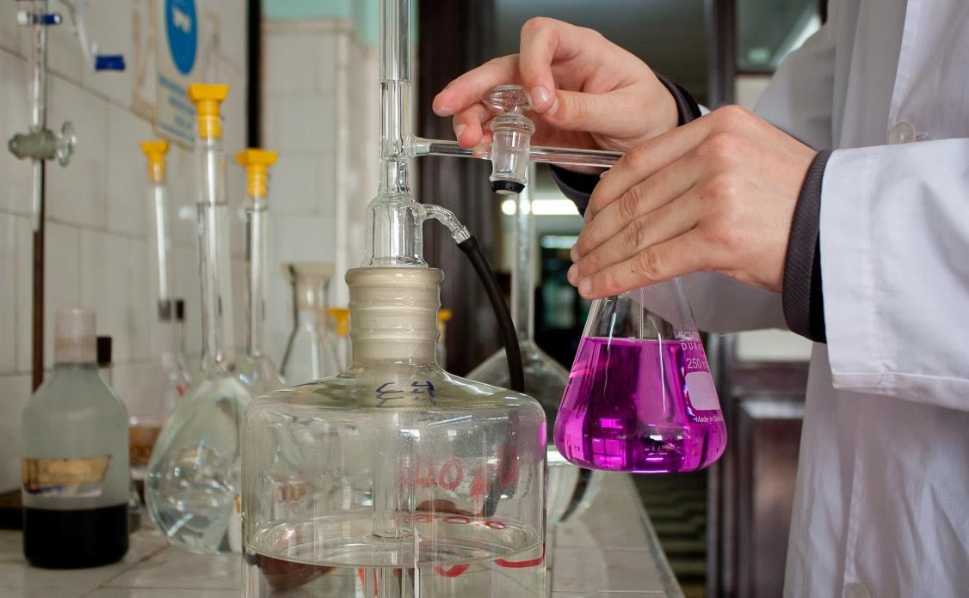
Pie de foto: En lo posible que las imágenes ocupen el ancho en la caja de texto.
Dejar un espacio entre el pie de foto y el texto/subtítulo que viene a continuación …..whofail in theirdutythroughweakness of will, whichisthesame as sayingthroughshrinkingfromtoil and pain. These cases are perfectly simple and easytodistinguish. In a free hour, whenourpower of choiceisuntrammelled

Título 1 | Título 2 | Título 3 | Título 4
Fila 1 | These cases are perfectly simple
Fila 2 |  | These cases are perfectly simple
Fila 3 |  |  | These cases are perfectly simple

